**Project Design Phase-II**

**Technology Stack (Architecture & Stack)**

|  |  |
| --- | --- |
| Date | 28 June 2025 |
| Team ID | LTVIP2025TMID59203 |
| Project Name | EDUCATIONAL ORGANISATION USING SERVICENOW |
| Maximum Marks |  |

**Technical Architecture:**

The Deliverable shall include the architectural diagram as below and the information as

**Example: Order processing during pandemics for offline mode**

During pandemics, educational organizations faced significant challenges in ensuring uninterrupted learning, especially for students without internet access. To support offline education, schools and colleges implemented measures such as distributing printed learning materials, using SMS for announcements, and coordinating lessons through local volunteers or community centers. ducational content was also broadcast via radio and television to reach wider audiences. These offline strategies allowed institutions to maintain academic continuity, support student engagement, and ensure inclusivity despite limited digital infrastructure.

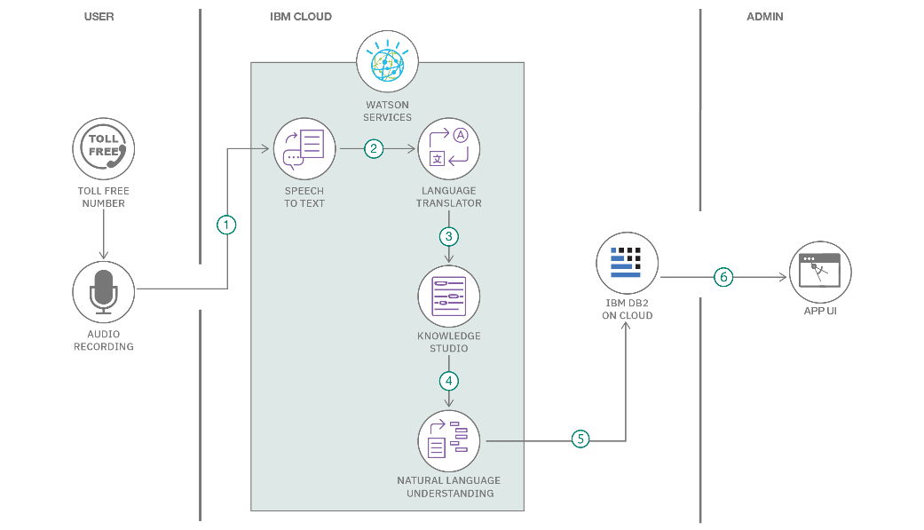

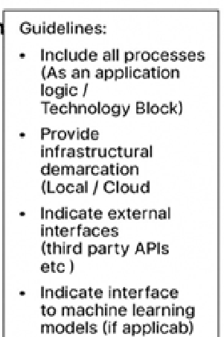

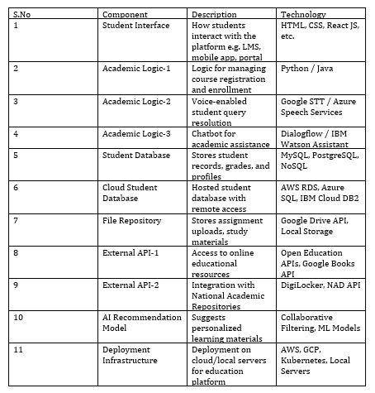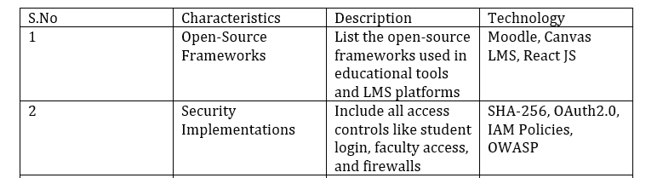

**Table-2: Application Characteristics:**

